**Instructor Read Me File for Tableau Data Visualization Class**

To begin, you will need to install Tableau. Please see below:

**\*\*\*Please note. Tableau Desktop Levels 1, 2, 3, and the Data Visualization classes are all taught with a FREE 14 Day Trial of Tableau Desktop which needs to installed before class begins.**

**John Farnum has graciously contributed the instructions to do a quick install on the student's computers. After these directions, please see the rest of the Read Me file for tips on where to find things, approximate lab timings and any suggestions for labs.**

**Enjoy your class!**

First Step: Install Tableau on Student Machines (Thank you John Farnum for your contribution on how to download tableau on all student computers at one time!)

1. To launch the Tableau Desktop Installer on all student workstations.

a. Use NetAdminLookout and choose the **Tools** tab.

b. Run Tableau Desktop installer located in the Downloads folder for each student.

[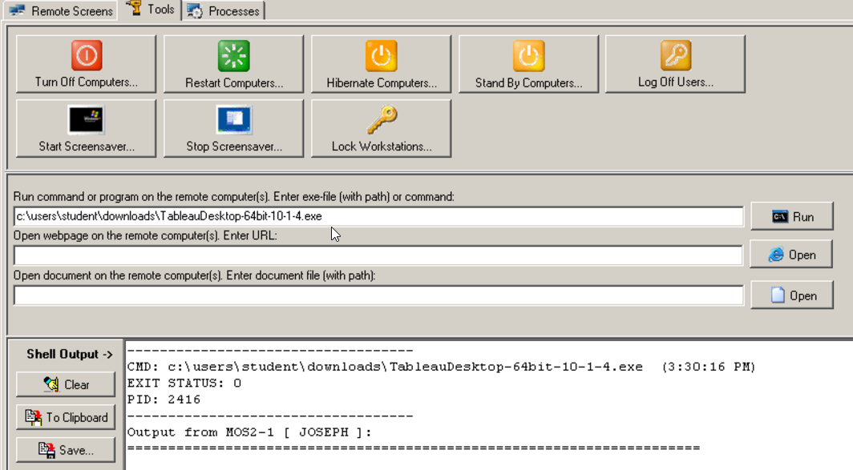](https://github.com/ONLC-Classes/XTBI10---Tableau-Desktop-Level-1/blob/master/media/image1.png)

c. Command path(example): **C:\users\student\downloads\TableauDesktop-64bit-2018-1-0.exe**

1. Choose **Run** command button and select All.
2. [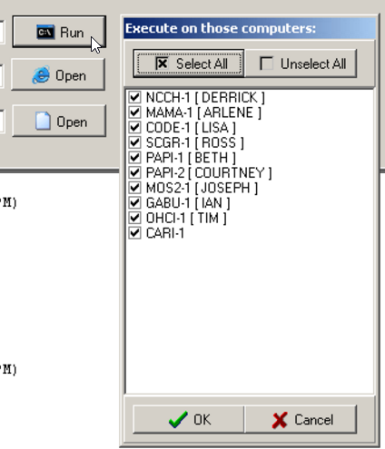](https://github.com/ONLC-Classes/XTBI10---Tableau-Desktop-Level-1/blob/master/media/image2.png)
3. Tableau Installation will begin on all selected student workstations. Remote into each workstation and choose Install.

[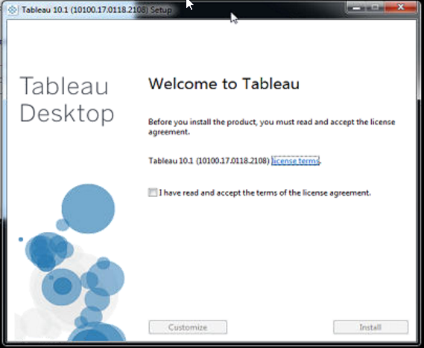](https://github.com/ONLC-Classes/XTBI10---Tableau-Desktop-Level-1/blob/master/media/image3.png)

1. Once installer completes, **Tableau Registration** form appears.

[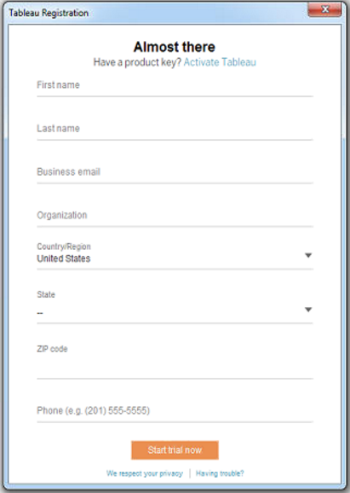](https://github.com/ONLC-Classes/XTBI10---Tableau-Desktop-Level-1/blob/master/media/image4.png)

1. CANCEL/Close out of this registration and return to the Desktop.
2. Restart **Tableau Desktop** application from the Desktop icon and the **Tableau Registration** form re-appears.

[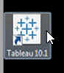](https://github.com/ONLC-Classes/XTBI10---Tableau-Desktop-Level-1/blob/master/media/image5.png)

a. **Notice** how the registration form is [now filled in with generic data from Tableau]{.underline}! All you need to supply is a series of numbers for a phone #. (Make it up)

[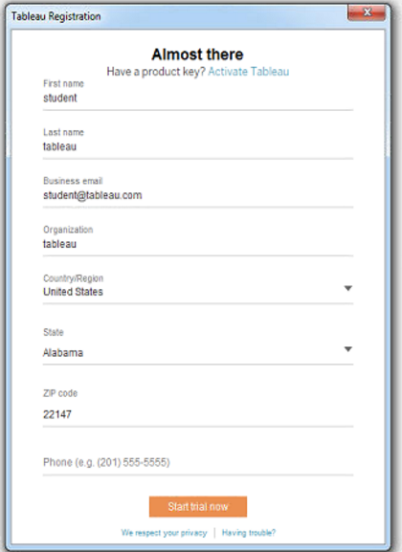](https://github.com/ONLC-Classes/XTBI10---Tableau-Desktop-Level-1/blob/master/media/image6.png)[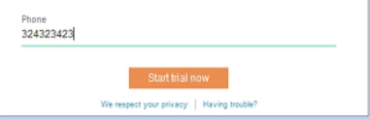](https://github.com/ONLC-Classes/XTBI10---Tableau-Desktop-Level-1/blob/master/media/image7.png)

1. Click **Start Trial Now**...and you are done! Tableau Desktop is now fully functional for 14-days and ready for your class.

**FILES FOR CLASS:**

Tableau Desktop Level 1 is the only Tableau class which has the files located on the desktop. This is because we do not want to overwhelm students who are new to Tableau, with learning about GitHub as well.

In saying this, github.com/onlc-classes is where we have ALL Tableau class files. Instructor Read Me’s, Power Point files to welcome students, workbooks, data sources, etc.

Github is something that we can change anytime we need to. So the concept is that it will stay updated for classes, as instructors find new ways to complete things, or find errors.

In every class besides Desktop Level 1, you will need to instruct the students to get their files from github:

1. Go to: <https://github.com/onlc-classes>
2. Choose the appropriate class (for this class, it is the Data Visualization link):
   1. https://github.com/ONLC-Classes/XTBD10---Tableau-Data-Visualization
3. Once on the correct repository, instruct the students to find the green “Clone or Download” button:

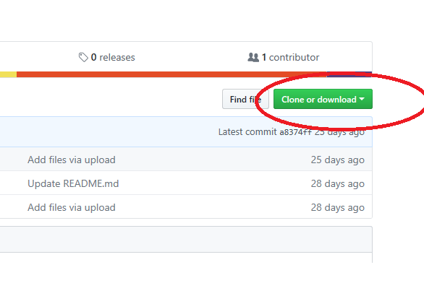

Once they click this, have the students save the files as a .ZIP file to their desktop. Do not worry that they will get all the files (including this read me).

1. After saving the zip file, the students should copy the “Workbooks” folder to their desktop, so they can use all the files needed for class.
2. After the students have installed all the files, be sure to have them open the workbooks and show them how the workbooks have .twbx files and some .xls data files and .csv files also. Each chapter has different data sources associated with it. **I would have the students use the EXCEL files as much as possible. The only reason they have BOTH excel and csv is because they might have Tableau installed on a machine without office!**

**STEP BY STEP through the two-day class:**

**\*\*\*Be sure to take notes as students introduce themselves. You will want to see for example, who works in a big company, small company, global company, government agency, etc. This is because throughout the book, you will want to call on people to chat about their work environment. This will serve to help ALL students understand that process is important, but different for all.**

**THERE ARE NO LABS FOR CHAPTERS 1, 2 and 12!!! All the rest are LOADED with labs. The students will be able to hear a word (like distribution, forecast, how much) and easily know which type of chart they should create for the business! An excellent class so they no longer have to guess!**

**A suggestion…. Chapter 13 is about Dashboards, Chapter 14 is about Advanced Dashboards. Depending on time, you could do chapter 13 and leave chapter 14 as optional or a workshop.**

**Day One - Try to complete Chapters 1-8, Day Two, Try to complete Chapters 9-14.**

**Since Chapters 1 and 2 should be very quick, you should have no trouble getting this schedule done. In longer chapters, you can skip labs and make them optional.**

**Day One====**

**Chapter 1 –** Length of Time to Spend (Approximately 30 minutes – depending on the size of class) – Get through as quickly as possible, but making sure that people understand WHY process is important.

***There are files for chapter 1, but you will not need them.

At the beginning of every chapter, there is a quote. They should be read with/to the students. They are fun and represent in most cases, a non-technical thought of each concept.

This is a “Principle” only chapter. You will ask the students to turn through the pages with you, going over the principals of communication. You need to stress that the old days of nobody communicating and just emailing your work to you, are over.

Communication is the work of a TEAM. This team needs to go through business process, in order to start and finish projects, according to requirements (including compliance).

To make the chapter more interesting, you should have introduced each student and should go to a few (or all, depending on class size). Ask them if their company has adopted any processes for creation of reporting and modeling. Find out who goes to meetings, who talks to the business, how they get their work, if they are administrators, or if they have an environment where they need to put tickets in, so the admins can post the reports. The point of Chapter 1 is to be sure of PROCESS. Gone are the days where people should just create reports without knowing why…

SPECIAL NOTE: on page 9 of Chapter 1, there is a picture (figure 1.6) that focuses on positioning. When the students work on Chapter 3 lab, it will point them to this figure. As you go over chapter 1, tell them that in chapter 3, it will ask them to refer to it, so get a good look at it now, so they don’t have to go back. 333333

**CHAPTER 2 –** Take approximately 30 minutes to get through this chapter. It is meant as a REVIEW of Tableau. There are many students who have never taken the other classes, or are self-taught.

Concepts that are most important:

--Pages 16 and 17 – Tableau Products

--Next, have the students open “[CDWT_ch2_NYBoroughs.twbx](https://github.com/ONLC-Classes/XTBD10---Tableau-Data-Visualization/blob/master/Workbooks/Chapter%202/CDWT_ch2_NYBoroughs.twbx)” located in the Chapter 2 Workbook Files. You can use this to go over pages 22-29. Focus on Measures and Data Types, calculations, mapping, and show me (even though we do not use show me much).

This is a tiny chapter, but allows you to get all students on the same page. You can either demo or get them to walk through with you. Mostly, the students will want to get their hands on something, so it might be better to walk through with them.

The pages are a bit hard to read, but you just need to get them to understand the basic fundamentals of the Tableau Interface. You can even make up your own walk-through, if desired.

=============

**IMPORTANT:**

**The students will have the choice to use their actual class book for labs OR now, as of 8/7/2019, there is a Student Lab document located in the root of this Data Visualizations Tableau Repository. The Lab book is easier, more clear and have more specific instruction. However, the book can be used for an extra challenge. Although the pictures are tiny, the lab instructions are clear to read. The WORKBOOKS folder that the students downloaded contains the SOLUTIONS. So in most cases, the students will start with a fresh tableau workbook for each chapter, or, if they desire, they can create one workbook for the entire class, but they will need to continually add data sources to that workbook and it might be easier to keep them separate.**

**They do not really need to save their work in each chapter, but can if they want to. Mostly, because the solutions are provided.**

===============

**CHAPTER 3 – HOW MUCH, HOW MANY -**  Take approximately 10 minutes to explain the concepts of this chapter (pages 31 and 32), then let the students loose to work on the labs (pages 33 – 50 in the book) – of COURSE at any time, you can do labs with students, demo them beforehand, etc. Judge the method you prefer once you assess the student body.

This is the first full chapter for the students. There are LOTS of hands on exercises for the students, but the main focus should still be the CONCEPTS of COMMUNICATION.

Chapter 3 is based on “How Much and How Many”. Some of the labs are “easy” to perform, but packed with power, because this is the first Tableau class we have that addresses these concepts one by one, and talks about what is a good way to present data, and in some cases what is a bad way.

**LAB TIME FOR STUDENTS – Approximately 45 minutes.- Pages 33-50 in their books.**

Once the students have completed the Labs, the instructor should go over each lab and talk about how it fits into the concept for that chapter (in this case How Much/How Many) – This should take approximately 45 minutes.

**\*\*NOTES:**

This chapter uses the “[CDWT_ch3_DSNY.xlsx](https://github.com/ONLC-Classes/XTBD10---Tableau-Data-Visualization/blob/master/Workbooks/Chapter%203/CDWT_ch3_DSNY.xlsx)” data source, located in the Chapter 3 Folder of the Workbooks Folder. This data is about NYC garbage collection tonnage. It also uses the NYC Rat Siting Data Set ([CDWT_ch3_NYCRatSightings.xlsx](https://github.com/ONLC-Classes/XTBD10---Tableau-Data-Visualization/blob/master/Workbooks/Chapter%203/CDWT_ch3_NYCRatSightings.xlsx)). This will give the students practice at adding a new data source.

**This chapter focuses on “Position” and how position is the choice for how much and how many. The book will ask the students to go to figure 1.6 in the book (page 9) to see the positioning concept.

The main points are that bar charts, sorting and swapping are the most effective charts to use for How Much and How Many.

The students should really use the “undo” or “clear” function to get a clean sheet in this chapter, rather than taking the time to create a new sheet for each task.

The show me box is used here to show students how Show Me is effective, but moves things around in Tableau, that they could also complete manually.

The DOT Chart is also introduced here. The students should be encouraged to play with Borough to “color” and then dragging it from color to Column. They should also play with the SIZE bar, swapping tool and formatting for color and grid lines to make their charts fulfill the how much and how many factor.

The last part of the lab is about “How Many” – this will introduce the concept of “Number of Records” to the students. It is crazy, but many people use Tableau every single day and do not realize that number of records represents their rows in the database.

The students will also replace the Boroughs field with City, only to find out that Brooklyn is spelled wrong in one of the records.

Lastly is the concept of histograms. The idea is that once we have clearly communicated how much and how many, there may be TOO much or TOO many. Histograms allow us to mark ranges of data for easier communication.

**PLEASE NOTE THAT the lab will take the students back and forth between the garbage collection and rat sightings data. This is GREAT because it shows that not all data is alike, but if you are answering the How Much and How Many questions, you do it with the same techniques, regardless of the data.

**CHAPTER 4 - RATIOS AND RATES -**  Take approximately 10 minutes to introduce the concepts for this upcoming Lab. Be sure to read the quote from Michael Bloomberg. It depicts the “why” of Ratio and Rates immediately. Explain the concepts of this chapter (pages 51 and the top of page 52).

With the students, create two calculated fields. Gives the opportunity for you to talk about how when we customize Tableau, with things like calculations, we truly give the business what they want and need. (also, the print in the book is tiny here, so it is much better for you to do it with them:

Start a new Tableau Workbook with the students and connect to the “[CDWT_ch4_DSNY.xlsx](https://github.com/ONLC-Classes/XTBD10---Tableau-Data-Visualization/blob/master/Workbooks/Chapter%204/CDWT_ch4_DSNY.xlsx)” data source in the Chapter 4 folder – located in the Workbooks folder)

Go over the bottom of Page 53 with them, explaining the types of data in this data source. (RefuseTonsCollected, PaperTonsCollected, MGPTonsCollected) – Basically it is the difference between garbage, recyclables and then recyclables are sorted into paper vs. other (metal, glass and plastic).

These are excellent data source types for ratio. Because we need to constantly compare.

Create the two calculated fields below with the students: Explain how the first one is to combine the recycling types together. Explain that the second field will give us the ratio of recyclables in general, to regular garbage.

RecyclableTonsCollected

[MPGTonsCollected] + [PaperTonsCollected]

RecylcetoRefuse Ratio

SUM([RecyclableTonsCollected]) / SUM([RefuseTonsCollected])

Now, on Pages 54-59, let the students loose for approximately 20 minutes to finish the labs that show Ratio and Rank. STOP them at page 63, so you can go into RATES and blending data sources (see below):

Page 63 RATES

The point of rates is that although we are talking about this garbage and recycling data, it currently hasn’t included anything with regard to population.

Have students read through page 63 with you, and make sure they understand that we need to add a new data source. On page 64, have them add the “[CDWT_ch4_NYCDistrictPop.xlsx](https://github.com/ONLC-Classes/XTBD10---Tableau-Data-Visualization/blob/master/Workbooks/Chapter%204/CDWT_ch4_NYCDistrictPop.xlsx) “ to the workbook. The table they will need is the 2010 population table.

After performing the actions with the students on page 64 (dragging the CommunityDistrict Measure from DSNY into Dimensions), Try to drag one of each Borough, and one of each Community District to test. After you do that, point out the little red links in tableau to show that the fields are connected through blending (rather than relational keys). Clear all the fields.

Create a calculated field with the students (from page 65): (be sure to drag all the fields in, instead of typing, so you can see how Tableau works with blended data. It is very clever using the prefix of the data source for your fields).

Refuse lbs by Person

2000 * SUM([RefuseTonsCollected]) / SUM ( Population) (this field will look much longer because you will drag from the other data source and it will include prefix info.

When this has been completed, Have the students create the chart on Page 66 – approx. 5 minutes.. (as the instructor, if you didn’t work on the labs in this class, you will be missing some of the fields below (if you did not complete the rank section). You can always open the solution to demonstrate during your lab go over/chat.

Basically, the final chart in Chapter 4 is as follows:

Column: AGG(Refuse Per Person)

Row: Rank, Borough and Community, AGG(Refuse Per Person)

**CHAPTER 5 – Proportions and Percentages -**  Take approximately 10 minutes to introduce the concepts for this upcoming Lab. Be sure to read the quote from Yogi Berra which sums the concept up nicely.

The data sources for this chapter focus on Baseball (stats) – That is a perfect data scenario to describe Proportions and Percentages.

The first data source used is: [CDWT_ch5_2012NYStats.xlsx](https://github.com/ONLC-Classes/XTBD10---Tableau-Data-Visualization/blob/master/Workbooks/Chapter%205/CDWT_ch5_2012NYStats.xlsx) (the 2012 Team Player Stats table)

The second data source used in this chapter is the [CDWT_ch5_AL_HomeRuns_2011-2012.xlsx](https://github.com/ONLC-Classes/XTBD10---Tableau-Data-Visualization/blob/master/Workbooks/Chapter%205/CDWT_ch5_AL_HomeRuns_2011-2012.xlsx) (only one table here – all team home runs)

The concepts in this chapter include filters, table calculations, Waterfall and Gantt charts, Bullet graphs and reference lines.

After you introduce the chapter, give the students approximately 30 minutes to do the labs depicted in this chapter. After they finish, have a go over (use the solution) and be sure they understand what they did. The chapter is easy peasy, but it is good to put two and two together. When the students realize that these concepts have to do with percentages and proportions, they will be excited. The next time the business asks them about it, they will truly understand how to give them what they want and need in Tableau.

**CHAPTER 6 – Mean and Median -** Take approximately 10 minutes to introduce the concepts for this upcoming Lab. Go through pages 87-89, using baseball again, to describe data distribution.

The data sources for this chapter focus on Baseball players and salaries.

The first data source used is: [CDWT_ch6_2012StatsMLB.xlsx](https://github.com/ONLC-Classes/XTBD10---Tableau-Data-Visualization/blob/master/Workbooks/Chapter%206/CDWT_ch6_2012StatsMLB.xlsx) (Sheet 1)

The second data source used in this chapter is the [CDWT_ch6_2012SalariesMLS.xlsx](https://github.com/ONLC-Classes/XTBD10---Tableau-Data-Visualization/blob/master/Workbooks/Chapter%206/CDWT_ch6_2012SalariesMLS.xlsx) (2012 MLS Salaries)

This is not a long chapter, you should be able to get through relatively quickly.

Once you introduce the chapter, be sure that you tell them which concepts they will be working with. Box Plots, (some through show me interface), filters, reference lines and outliers. The students should be able to work independently with no issues.

Students need 20-30 minutes to complete the labs in this chapter, then you can have a lab chat. – There will not be loads of questions on this chapter.

**CHAPTER 7 – Variation and Uncertainty -** Take approximately 15 minutes to introduce the concepts for this upcoming Lab. Go through pages 101 through the top of 107 to introduce the concepts of Control Charts. Variation over Time.

The students will be definitely tired by this time and will appreciate that you will go through a few labs with them. There are some you will then use the solution for, in order to finish the labs quickly. The last few labs have data in them revolving around a chess club. While certainty and uncertainty are something you will discuss with the solution, there is way too much work to have everyone do everything.

**NOTE: There are .doc files in this chapter’s folders. They contain the calculation code for the longer calcs. This will be left for the student to do on their own time, after class ends. But you should go over the entire folder, point out the .twbx files, point out the data files and the .doc files.

After you have the chapter overview, have the students (with you) start a new Tableau. Have them use the “[CDWT_ch7_Earthquakes.xlsx](https://github.com/ONLC-Classes/XTBD10---Tableau-Data-Visualization/blob/master/Workbooks/Chapter%207/CDWT_ch7_Earthquakes.xlsx)” data. This data is about Earthquakes and is a great help to introduce “Control Charts”.

Have the students turn to page 108 with you. You are asked to create a simple chart with the YEAR(Date & Time) on the COLUMNS and Number of Records on rows. In the book they show a picture which looks NOTHING like what they have. Ask the students who knows WHY?????

The reason in the end is because the Date and Time field isn’t a date at all. It is a string field. With the students, change this field to Date and Time. (right click and change to Date and Time). Have them clear the column shelf and drag the new date and time field in. THEN have them change to continuous.NOW their picture will look like page 108.

Once that is done, go over the bottom of Page 108 by adding two reference lines through the use of the Y-Axis. One is for Average and one is for standard deviation. Nothing will look out of the ordinary yet.

Have them change the Column Year pill to Continuous Month. Have them flip to page 110. Show them the “outlier”. Show them how outliers an point to data which is “not normal” and can show immediate variation.

Next, have them duplicate the existing sheet.

THEN… have them click the “number of records” pill and add a quick table calculation called “moving average”.

Drag a second instance of “number of records” next to the first one on the shelf. Add a quick table calculation called “difference”.

Go to the first pill, and using the MARKS shelf, change the chart type to “line” – Change the chart type for the second pill to “circle”. Then click the arrow in the second pill down and select “dual axis”. The idea here is that we can use different calculations on this chart for the purpose of comparison.

AT THIS POINT, close and do not save this workbook. OPEN the solution. Go over pages 110-114 to continue talking about variation. Open the three calculations listed on page 112 (using edit open MR_UCL, UCL and LCL. Notice they are all using the Moving Range calculation. This is your second pill. Go through the rest of the charts and show how earthquakes have been studied for variation.

Next, ask the students to turn to page 115 and look at the chart on page 116. This is about uncertainty. Talk about uncertainty and how it is a powerful tool to use for things like trending and outcome.

Open the solution called “ConfidenceIntervals.twbx” Go over the chart, using pages 117-122 to understand uncertainty. Especially explain the “error bars”. These bars represent possible errors to be made. These are statistics using “possible moves” in a chess game and which will cause errors. Although this is probably not cut out for most people and their real world work, it is a good example of confidence levels.

Lastly, open the solution in this chapter about variation. Take a quick peek at some solutions which show variation. Explain that when the business asks for variation, it can be about time or it can be about chess moves, but it needs a range of data that includes the “it is” or it “is not” factor. And given enough of these binomial values, you can see the variations, which will hopefully help with analyzing business trends.

**CHAPTER 8 – Multiple Quantities –** Go over page 125 with students. Talk about how seeing things in a “hunk” mostly represents where there is more data. For example, a real estate map, showing a clump of properties for sale, could indicate that there is a problem (such as floods) in that area.

The students will work on this chapter and labs until they go home on day one (if that is how your day went. If not, the first thing in the morning will also be fine).

The concept of data in this chapter has to do with the National Hockey league, including scores and a famous player, WAYNE GRETZKY.

There is only one data source for them to use: [CDWT_ch8_NHLTop100.xlsx](https://github.com/ONLC-Classes/XTBD10---Tableau-Data-Visualization/blob/master/Workbooks/Chapter%208/CDWT_ch8_NHLTop100.xlsx)

And at some point, they will also use a photo: [wg.jpg](https://github.com/ONLC-Classes/XTBD10---Tableau-Data-Visualization/blob/master/Workbooks/Chapter%208/wg.jpg)

These files can be found in the workbooks folder, under Chapter 8.

There is a calculation on page 138 that may be hard for the students to read. It is:

Goals Per Game

Sum([G]) / Sum([GP])

This lab is an excellent example of using trend lines and looking at trend models.

Save the lab chat for Day 2, unless they did lab 8 on day two. Then do it immediately after.

The labs are excellent and will help the students to know that when the business gives them data that “clumps” together, they may wish to use things like scatter plots and trend lines to point to the data.